**Scheduling WebJobs**

WebJobs can run on-demand (when run from the portal), continuously (and possibly in response to input from a Storage blob, Storage queue, or Service Bus queue), on a scheduled date and time, or at certain recurring intervals within a specified date range. The schedule to use depends on your scenario. Scenarios that run only occasionally may work best as on-demand; scenarios that run in response to input from storage or service queues should run continuously; others may need to be scheduled according to the calendar.

In the previous example, the WebJob was configured to run continuously. If instead you want the WebJob to run on a schedule, you can complete the following steps to reconfigure it in Visual Studio and then re-deploy:

1. With the project open in Visual Studio, open Solution Explorer.
2. Expand the project, and then expand Properties. Right-click the file named Webjob-publish-settings.json, select Delete, and then confirm the selection in when prompted. You will re-create this file later using the Add Azure WebJob dialog box.

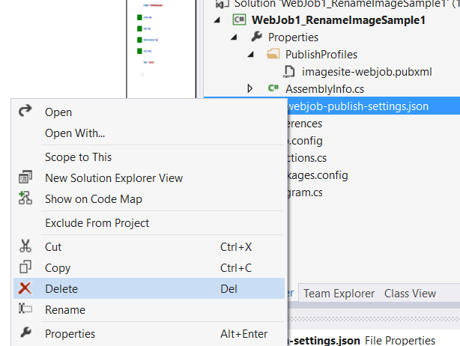

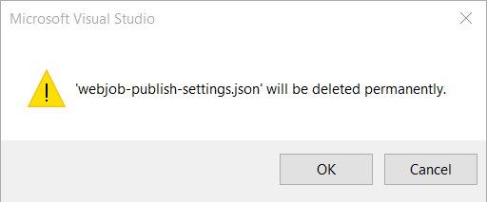

1. Return to Solution Explorer, right-click the project and select Publish As Azure WebJob.

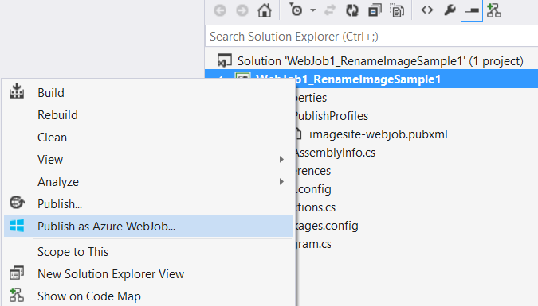

1. In the Add Azure WebJob dialog box, select Run On A Schedule in the WebJob Run Mode list.

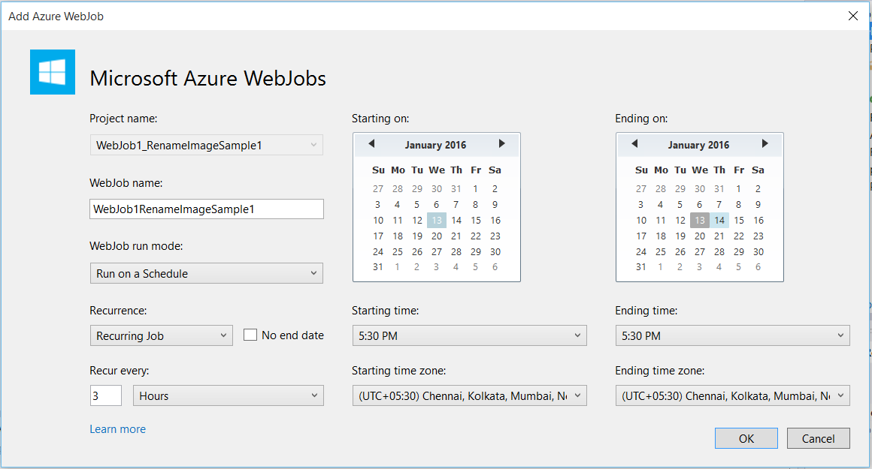

1. Specify a recurrence, a starting date and time, and, if you selected Recurring Job as recurrence, specify an ending date and time and a recurrence pattern (for example, Recur Every 1 Day).



1. Click OK to re-create the Webjob-publish-settings.json file with the new configuration and open the Publish Web dialog box.
2. Click Publish to deploy the WebJob with the new schedule.

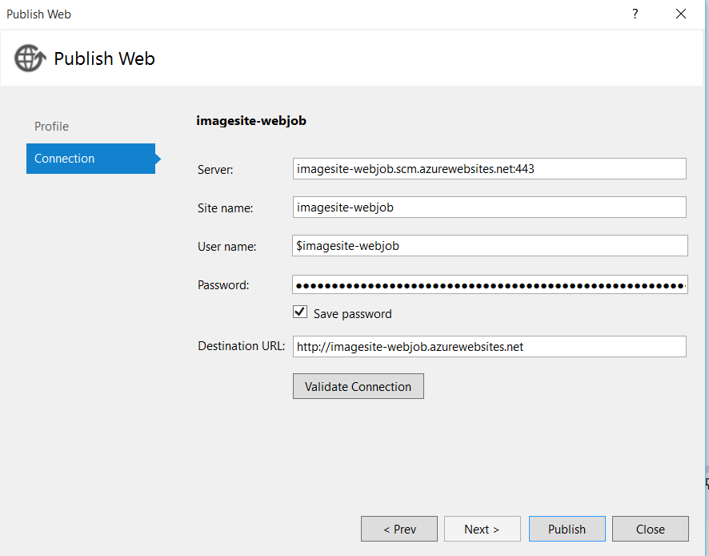

When time set to schedule automatic webjob will start. Images will renamed & uploaded on output folder.

